Unique Capabilities of Green-AeroSM
- Tools can be assembled from blocks or units to produce complex tools or achieve large sizes

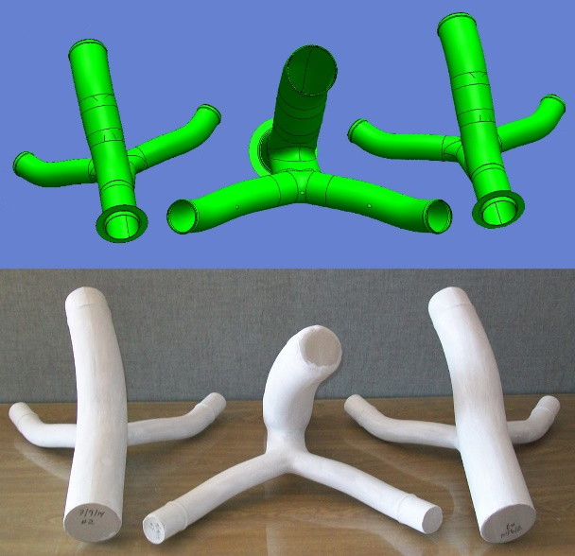
- Suitable for rate manufacturing

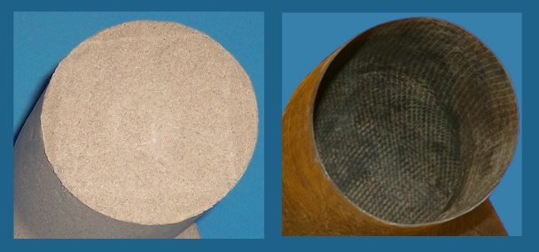
- Washout mandrels are usable for manufacturing up to 340°C (650°F) and 1400 kPa (200 psi)

- Master or mold sees room T only, and only rough vacuum
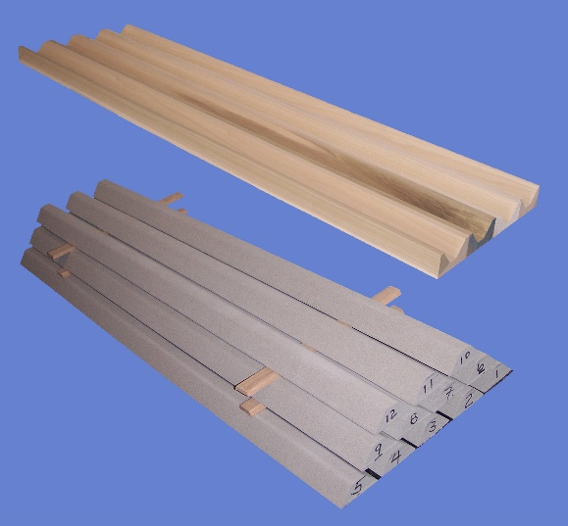
Since it is removed before tool hardening the master or mold may be made from almost any material, including a rapid prototyping model, original part, tooling foam, or even wood.
1.2-meter (4-foot) hat stiffeners made in wooden molds

- This is GREEN tooling; all steps are environmentally benign
  - Materials used
  - Production
  - Use
  - Washout

NCI Brochure 2018-11, Rev. 0, LLC

Nevada Composites Inc.
Green-AeroSM – the next generation in rapid tooling
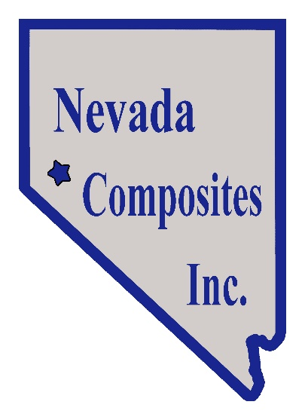

When a demanding mission requires both speed and affordability, look to Green-AeroSM tooling from Nevada Composites.

When you want it, where you want it, and at a price you can afford.
Green-AeroSM tooling from Nevada Composites Inc.
Nevada Composites' innovative tooling represents the next generation in rapid tooling for composites prototyping, manufacture, and repair
Green-AeroSM tooling
- Is based on ceramic microspheres in a water-soluble refractory binder
- Uses a vacuum-casting technique and ceramic tooling material adapted from the metal foundry industry.
- Combines simplicity, reliability, and flexibility in a robust but rapid tool-making process.
- Is available as custom single-sided tooling or custom washout mandrels
- Company History
Nevada Composites was founded in 2008 to bring lower cost, more time-efficient advanced tooling to aerospace and commercial markets.

Advantages of Green-AeroSM tooling from Nevada Composites Inc.:
- Short lead time
- Low cost
- Green
- Accurate, reliable, and reproducible
- Dimensionally stable
- Lightweight
- Low, composite-compatible CTE
- Low thermal mass
- Stand alone
- Tailorable
- Warm-water washout even after exposure to high cure temperatures

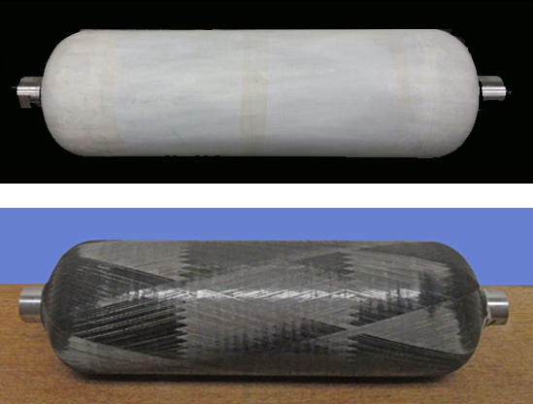
We would be happy to discuss your tooling needs. Solving complex problems and enabling leading-edge solutions is our specialty.

Contact Us:
Nevada Composites, Inc.
P.O. Box 2174; Dayton, NV 89403
775-246-5999; fax 775-246-0550
info@nevadacomposites.com
www.nevadacomposites.com

