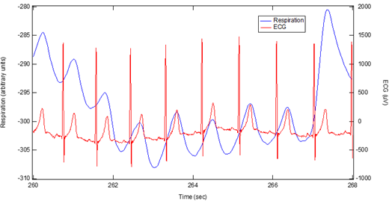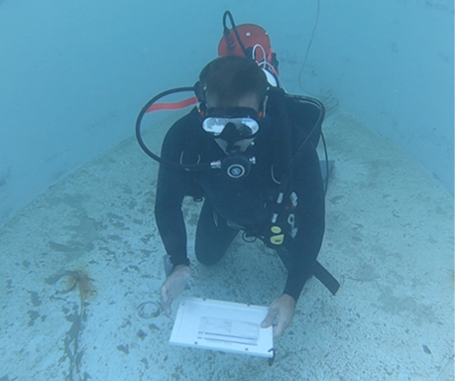

QUASAR is partnering with Scripps Institution of Oceanography for access to their saltwater diving pool and trained divers.

The collaboration allows QUASAR to develop its technology in an iterative manner, testing the device on divers underwater and making improvements as the project goes along.

QUASAR’s unique electrodes enable a comfortable device that allows divers freedom of movement underwater while providing necessary information on their physical state and health.



Diver Biometric Device

**Contact Us**

Quantum Applied Science & Research (QUASAR), Inc.

Phone: 858 373 0231

Email: info@quasarusa.com

Website: www. quasarusa.com

Connect with us on LinkedIn!

Sensing a World of Potential®





**Market/Customers**

QUASAR is currently working with the US Navy, the US Air Force, the National Institute on Drug Abuse (NIDA) of the National Institutes of Health (NIH),  The National Institute on Disability, Independent Living, and Rehabilitation Research (NIDILRR), and NASA.

The Navy project seeks to develop the Diver Biometric Device shown here.

In addition to our work with the government, QUASAR has conducted research with the University of Texas, Children’s National Hospital, and numerous commercial ventures.

**Commercialization**

QUASAR has a relationship with Wearable Sensing ([www.wearablesensing.com](http://www.wearablesensing.com)), which conducts commercial production and sales of QUASAR-developed technology.

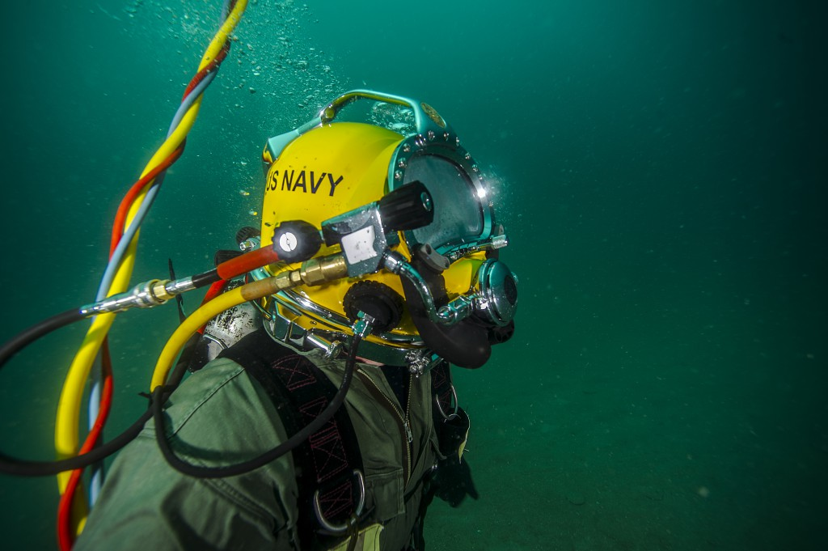

**Company History**

QUASAR was founded in 1998 to explore applications of electro magnetic sensing and has expanded into a specialty biosignal acquisition and interpretation business.

The Navy desires to acquire ECG and other physiological measurements on divers underwater, and QUASAR is developing waterproof electrodes and other sensors for a Diver Biometric Device (DBD) to provide ECG, respiration, skin temperature, activity and other measurements in saltwater and at depth.

**Mission/Vision Statement**

QUASAR develops and commercializes innovative non-invasive sensors, algorithms and solutions for physiological monitoring applications.

**Core Competency**

QUASAR is a world leader in noninvasive biosensing systems. Our work builds on our revolutionary noninvasive sensors integrated with precision hardware and sophisticated, robust algorithms to produce systems that output information about cognitive and physiological states.

**R&D**

QUASAR has a robust R&D program exploring applications of our innovative sensing devices. We have worked with the DOD, the NIH, the NSF and other agencies investigating applications as diverse as cognitive state monitoring, education, training, pain management, infant ECG and EEG, and Brain-Computer Interface (BCI).

**Services**

QUASAR can provide full service R&D for biosignal applications – from concept through design, mounting structures, through data acquisition hardware and interpretation software, to user-friendly interfaces to display the results the customer needs.



