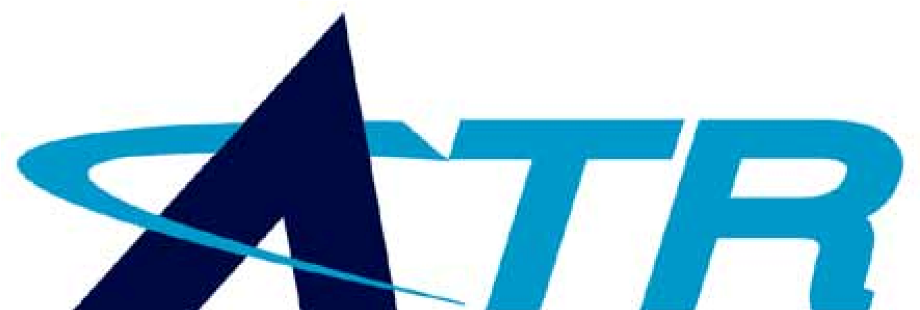

ATR provides specialty R&D services, automation products and technical support services to defense and other federal customers.

**Advanced Technology & Research Corporation**

**42**

YEARS OF

**ENGINEERING**

**EXCELLENCE**

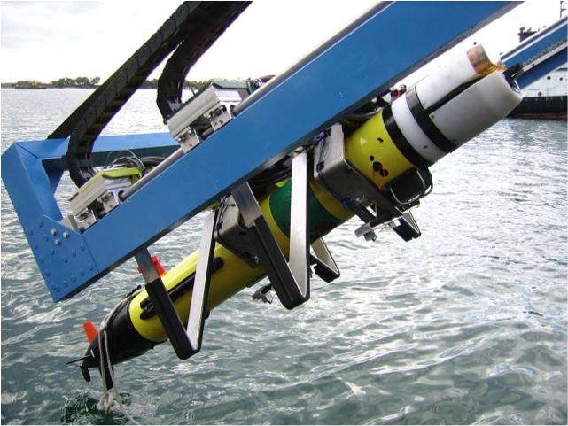

**PRODUCTS and SERVICES**

The Company provides a focused range of R&D services, prototyping, manufacturing and technical support services through three interlinked business units.

**CORE COMPETENCIES**

Engineering creativity and product innovation in robotics and automation are central to ATR’s mission.

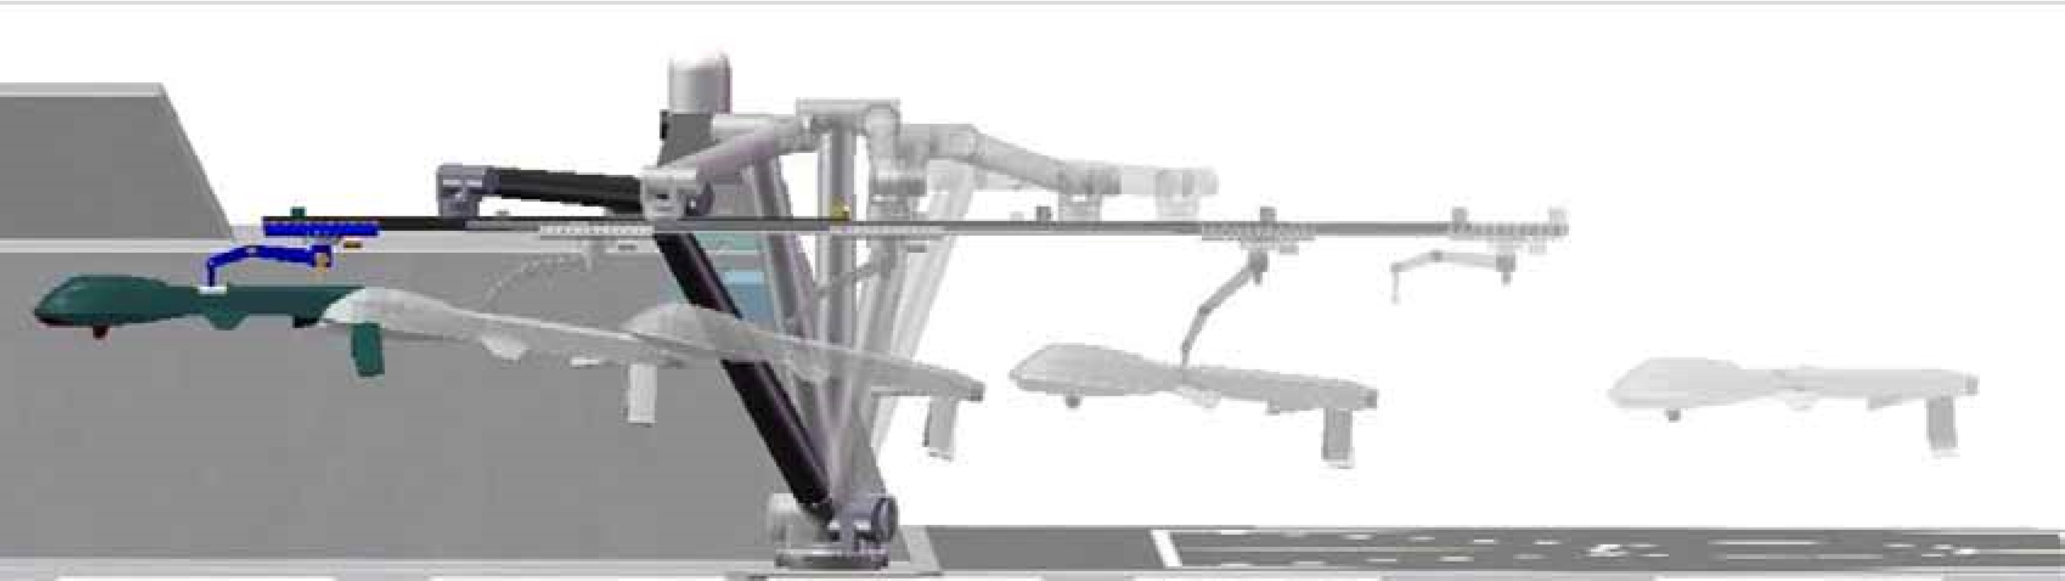

This ATR unit develops robotic systems and sophisticated control software for variety of Naval and other defense applications. It is increasingly active in designing and prototyping launch and recovery systems for air, surface and subsea unmanned vehicles operated from diverse host platforms. A related specialty is the development of motion-compensating stabilization systems enabling Naval logistical operations at sea. The team utilizes a variety of advanced sensing techniques to measure motion, position, dimensions and acoustical properties.

**Robotics and Control Systems Division**

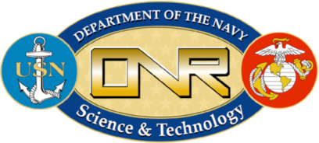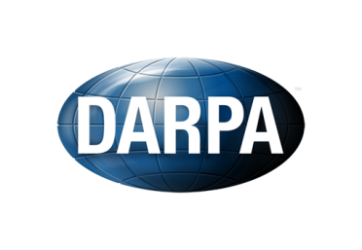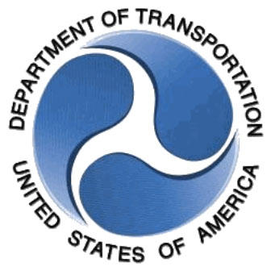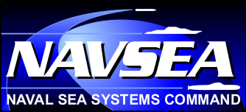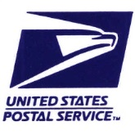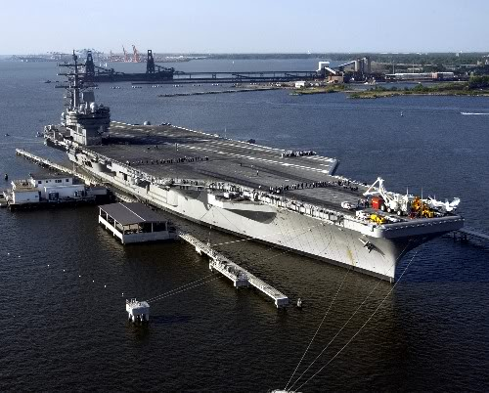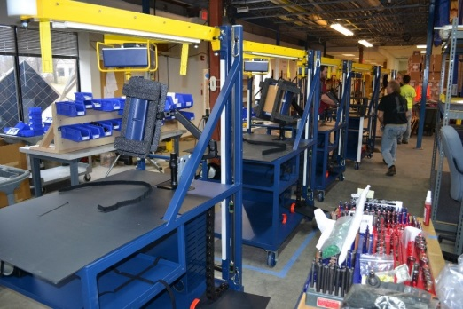

This ATR team provides a variety of technical support services to the Navy in the field of electromagnetic signatures for surface ships and submarines. ATR’s flexible and cost-effective on-site team also supports daily operations and facility upgrades. In addition, the team provides deep and hard-to-find technical knowledge in several other engineering specialties, including blast modeling and simulation, hypersonic weapons and weapons safety.

ATR’s Automation team designs, builds and manufactures automation systems, principally for the US Postal Service. It also collaborates with ATR’s Robotics and Control Systems team to produce prototypes and deployment hardware. The group has an excellent record for delivering ingenious and cost-effective systems that perform well in real-world environments.

ATR partners with DoD prime contractors, commercial sector companies and research institutions to deliver the best results for our customers. In recent years ATR has had fruitful partnerships, as subcontractor or as prime, with Raytheon, General Dynamics, Northrop Grumman, Lockheed Martin, Oceaneering, Applied Research Associates, Woods Hole Oceanographic Institute and others.

**PARTNERS**

ATR predominantly serves the Federal Government and its prime contractors. The US Navy and US Postal Service are our most important customers.

**MARKETS and CUSTOMERS**

**Engineering Systems Division**

**Automation Division**

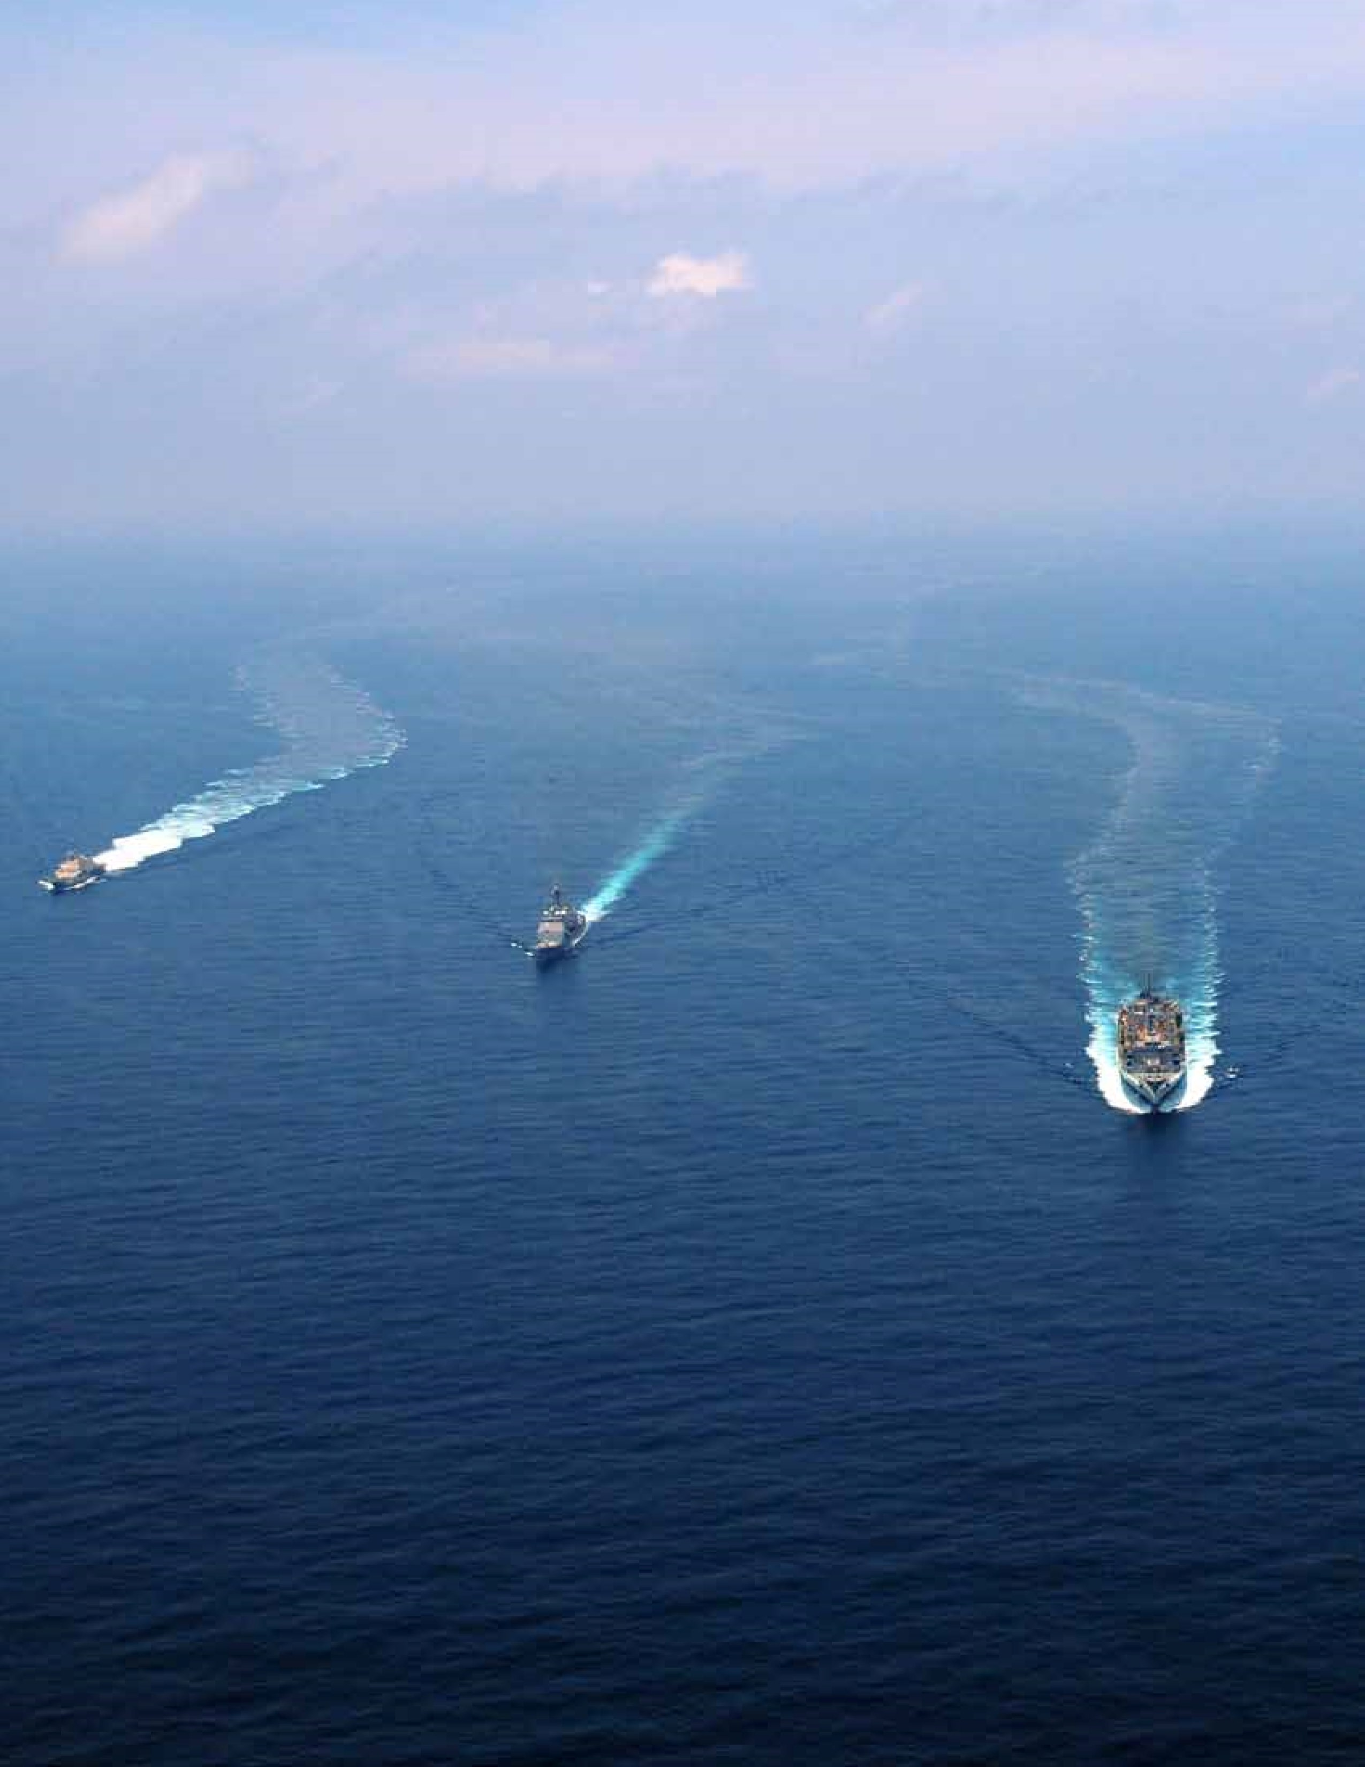

**PROFILE**

ATR has been led since its founding in 1973 by Dr. Jackson Yang, Professor Emeritus of Mechanical Engineering at the University of Maryland and former Director of its Robotic and Structural Dynamics Laboratories. Many of the Company’s fine engineers are graduates and advanced degree holders of the University of Maryland. ATR’s ranks also include many with extensive technical and managerial experience gained at Navy research labs in the DC area. About 80% of ATR’s 100 employees hold Secret or higher-level clearances. ATR’s 25,000 sq. ft. facility in Columbia, MD maintains a Top Secret Facility clearance. ATR follows ISO 9001:2008 quality management practices.

**CORE ADVANTAGE**

Whether in robotic systems, automation solutions or specialty engineering services, ATR’s customers discover excellent value in working with us. We are proud of our reputation for:

* Engineering Creativity
* Experience
* Capabilities from concept through to production
* Powerful analytical and control techniques
* Multi-disciplinary approach
* Cost-effectiveness

**CONTACT**

For further information, please contact:

**Dr. Jackson Yang**

(443) 766-7888

jyang@atrcorp.com

or visit ***www.atrcorp.com***