

ANDRO Computational Solutions, LLC, a privately owned company established in 1994, is dedicated to research, development, and the application of advanced computer software for a variety of applications. ANDRO’s diverse portfolio includes: research and development in electromagnetic environmental effects on systems, dynamic spectrum management, spectrum exploitation, cyber-secure wireless communications, cognitive radios and software defined networking, multi-sensor and multi-target tracking, advanced radar date fusion, and sensor resource management. Located in The Beeches Professional Campus in Rome, NY, ANDRO provides research, engineering, and technical services to defense and commercial industries.

**GOALS AND VISION**

**Our Vision:** To continue to provide customers computer modeling (particularly CEM) and simulation that involves the application of artificial intelligence and expert system technologies operating in a collaborative, distributed, high-performance computing environment.

**Our Goal:** To satisfy customers’ requirements by applying smart tools and solutions such as complex system EMC analytical studies and the development of optimized methods for efficient spectrum management including secure communications and cyber security. ANDRO fulfills Integrated Product Team development needs while enhancing productivity and competitiveness in a global market. Our products and services give our customers a competitive edge through the efficient application of simulation-based technologies.

**Our Values:** To develop and implement strategies that assure robust and cost-effective solutions to our customers’ problems using software tools to offset life cycle costs associated with system development; namely, costly and extensive testing and evaluation. ANDRO believes in the necessity of being part of the community, effectively brokering relationships with political, technical, and commercial partners..

**Contact Us**

**Address:**

**The Beeches Professional Campus**

**One Beeches Place**

**7980 Turin Road, Bldg. 1**

**Rome, NY 13440-1934**

**Phone:**

**315.334.1163**

**Email:**

**androcs@androcs.com**

**Website:**

**Androcs.com**

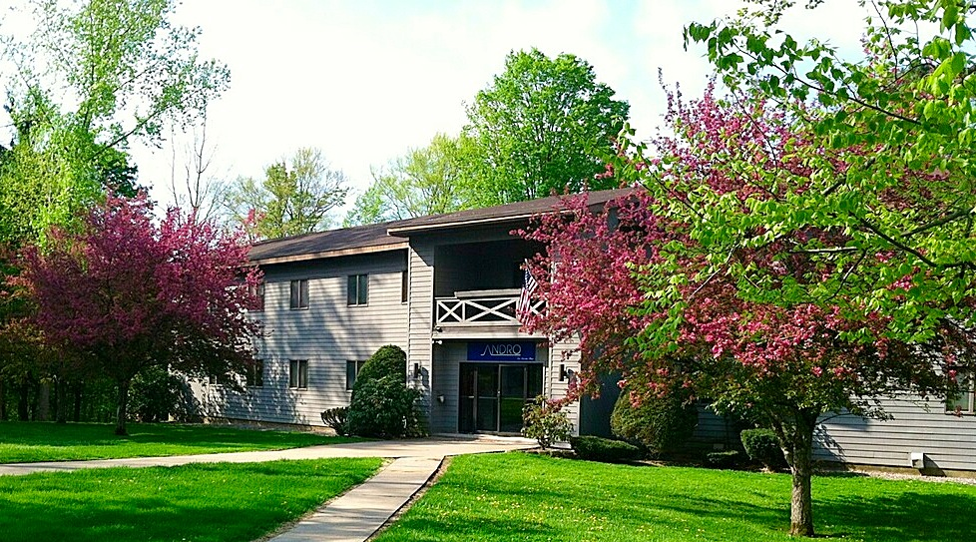



Innovation…

from the Inner Mind

to the Outer Limits

from Research to Systems

**ANDRO Computational Solutions, LLC**

**The Beeches Professional Campus**

**One Beeches Place**

**7980 Turin Rd., Bldg 1**

**Rome, NY 13440-1934**

**P(315) 334-1163 F(315)334-1397**

**Andrew L. Drozd**

**adrozd@androcs.com www.androcs.com**

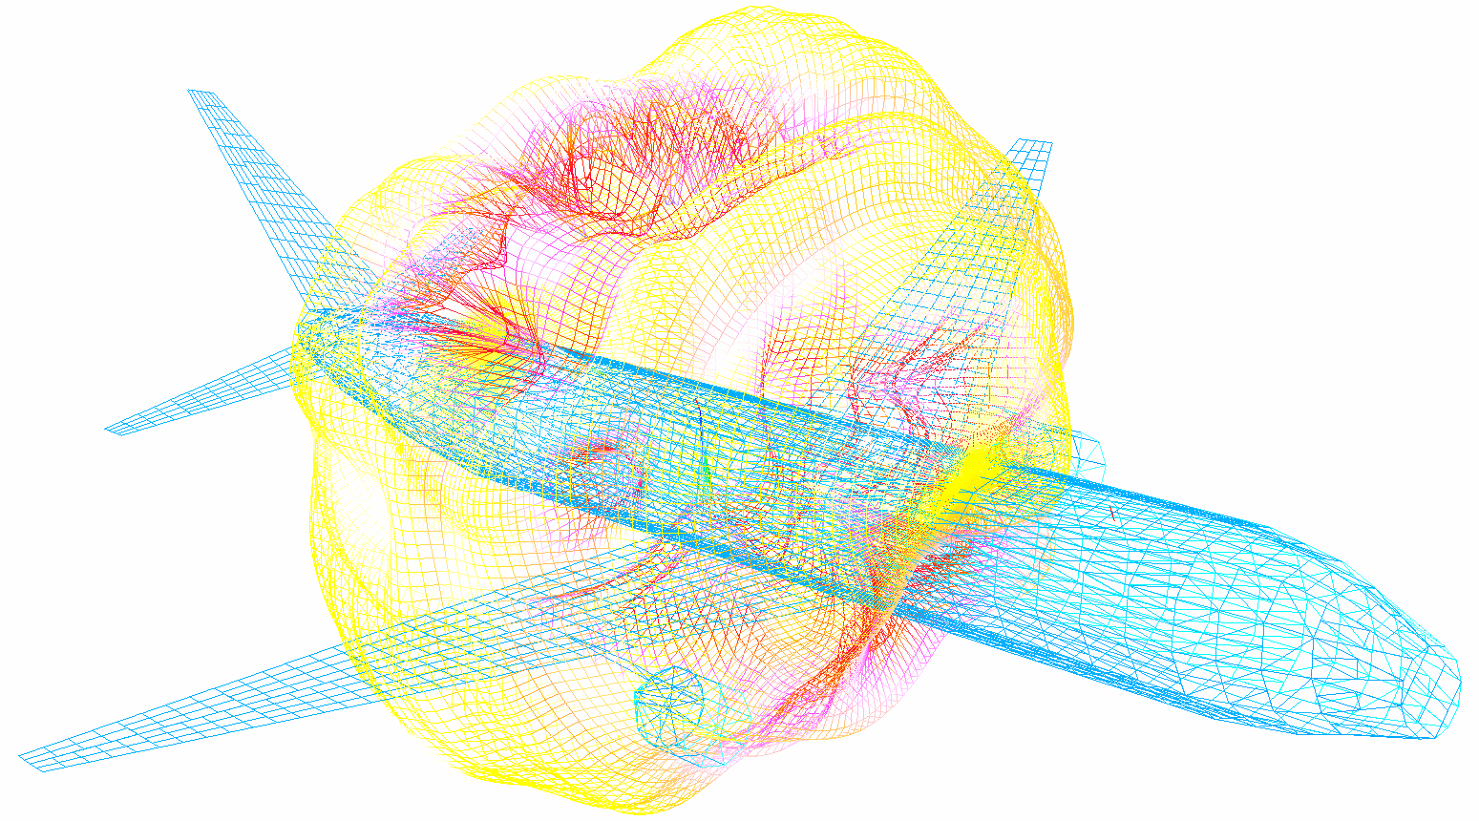

**CORE COMPETENCIES**

**Electromagnetic Simulation**

* High-Power Microwave Failure Analysis *(HPM Expert)*
* Intelligent Computational Electromagnetic Expert System

*(E3 Expert)*

* Environment effects of systems including High-Power Electromagnetics *(HEMP)*
* Electromagnetic Susceptibility Threshold Analysis Techniques by Estimation & Statistics *(EMSTATES)*
* Improved Analysis Techniques for Prediction of Avionics EM Interference/Vulnerability

*(Integrated EM Pro System)*

* Enabling cognitive radios & Secure Communications
* Advanced Radar Data Fusion & Multi-Sensor Information Fusion for Multi-Target Identification, Tracking and Discrimination
* MIMO Communications and Radar Systems

**MARKET/CUSTOMERS**

**Government Customers**

* Air Force Research Laboratory
* CERDEC
* Missile Defense Agency
* NASA
* Office of the Secretary of Defense

**Commercial Customers**

* Assured Information Security, Inc.
* Eaton Corporation
* ITT Industries-Advanced Engineering & Sciences
* Lockheed Martin
* Northrop Grumman
* Raytheon
* Rockwell Collins
* SAAB / Sensis Corporation
* Underwriters Laboratories
* Harris Corporation
* SAIC
* NASS

**International Customers**

* Australian Military Defense
* German Airborne Defense Systems (EADS)
* Spain Airborne Defense Systems (EADS)
* Israeli Air Force
* Canadian Department of National Defense

**Academic Research Partners**

* Syracuse University
* Pennsylvania State
* Lehigh University
* University of Illinois
* Ohio State University
* Oklahoma State University
* The University of Texas Arlington
* University of Buffalo
* SUNY Polytechnic Institute

**CORE COMPETENCIES**

**Communications & Cyber Security**

* Automatic Modulation Classification *(AMC/SIGINT)*
* Cyber Domain Spectrum Exploitation *(CyberSE)*
* Ad Hoc Cross Layer Networking through Optimized Joint Cognitive Routing and Spread-spectrum Channelization *(XLayer)*
* Secure Communications *(Transmission CyberspaceTM)*
* Spectrum Engineering/Management & Dynamic Spectrum Access *(Transmission HyperspaceTM)*
* Towards Maximal Spectral-Efficiency Networking Sensor Systems
* Enabling cognitive radios & Secure Communications

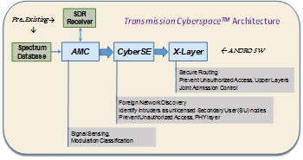

**Sensor Systems**

* Automated Target Characterization *(ATC)*
* Sensor Resource Management *(SRM)*
* Multiple Input Multiple Output Sensor Acquisition *(MIMOSA)*
* Radar Date Fusion and Registration *(Data FusR)*
* Spatial Multi-Sensor Autonomous Registration Toolkit *(SMART)*
* Sensor Management *(SENMAN)*
* Low-cost sensor network signal sensing and automatic modulation classification of weak signals