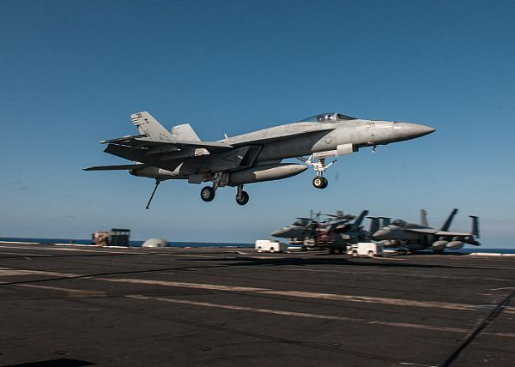

**Contact Us**

**Systems Technology, Inc.**

**13766 Hawthorne Blvd.**

**Hawthorne CA 90250**

**David Klyde**

**VP & Technical Director, Engineering Services**

**Phone: 310 679-2281 x127**

**Email: dklyde@systemstech.com**

**Kevin Maris**

**Head of Business Development, Commercial Engineering Services**

**Phone: 310 679-2281 x161**

**Email: kmaris@systemstech.com**

**Website: www.systemstech.com**

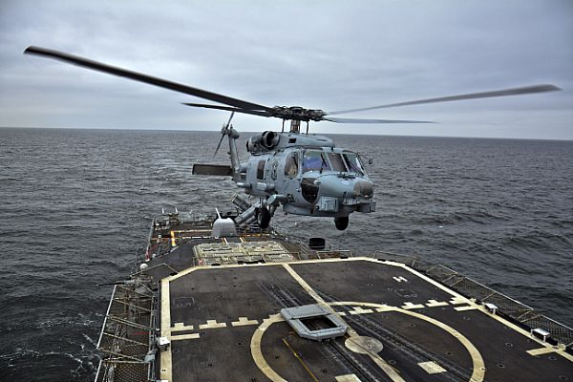

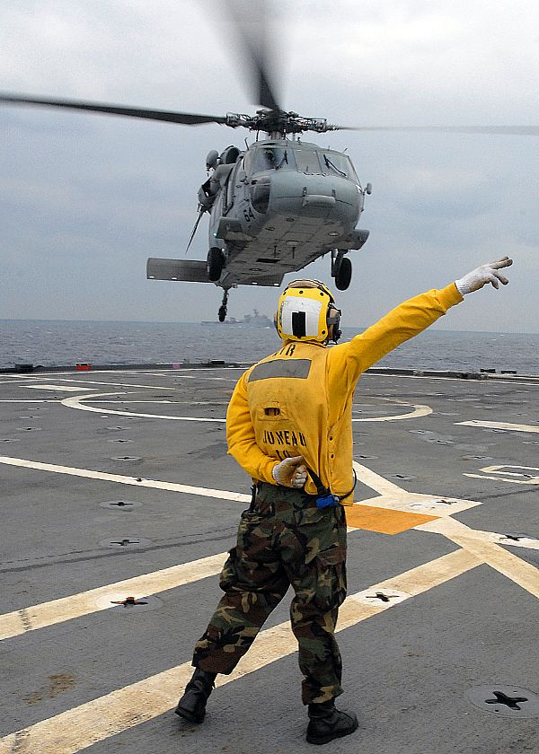

**Where complex dynamic systems and human operators intersect.**





**Advantage**

**- Six decades of corporate experience**

**Use Time and Frequency Domain Techniques**

**Employ Modern, Classical, Optimal, Robust, and**

**Adaptive Control Methods**

**Conduct System Design Audits**

**C-2A, CH-53E, F-4, F-14, F/A-15, T-45, V-22**

**Recognized Industry Experts in Aircraft Handling**

**Qualities and Pilot-Induced Oscillations**

**Developed Advanced Aeroservoelastic Analysis**

**Methods and Modal Suppression Techniques**

**Design and Analysis of Fly-by-wire Systems**

**- Cutting Edge Design & Analysis Methods**

**Wavelet-based Time-varying System Analysis**

**Pilot-vehicle System Loss of Control Mitigation**

**Output-only Modal Identification**

**Active Inceptor Cueing**

**Aircraft Ground Handling**

**- Value proposition**

**Solve complex dynamic problems through a thorough understanding of the fundamental underlying physics and mathematics.**

**Begin with the simplest model that captures the dominant system behavior and then build up complexity as needed to capture higher order effects.**

**Bring comprehension of the human operator and the human-machine interface.**

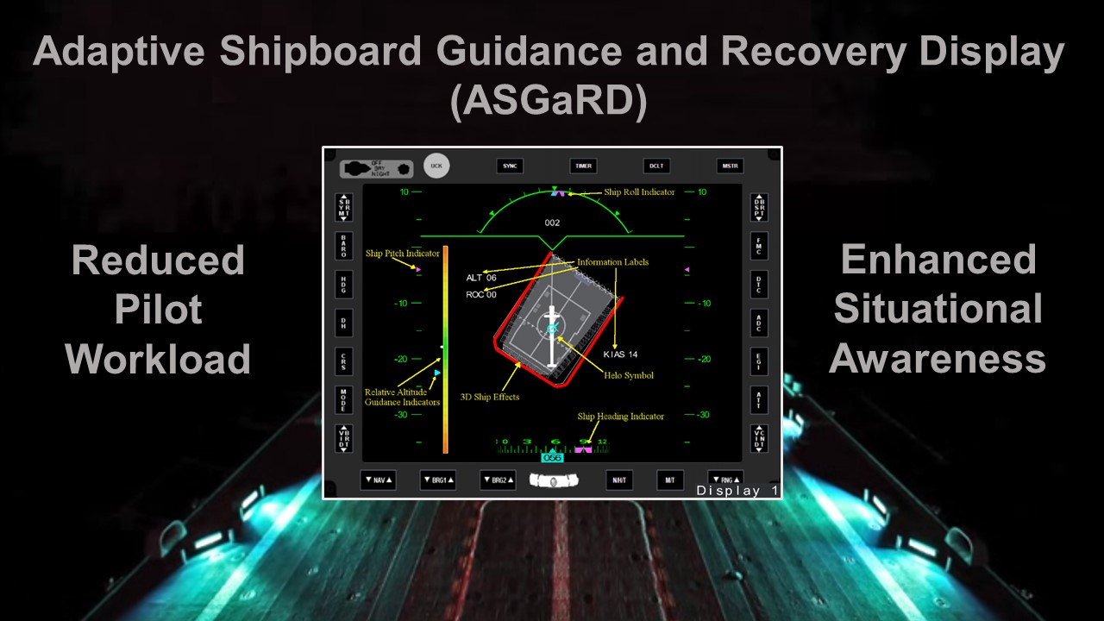

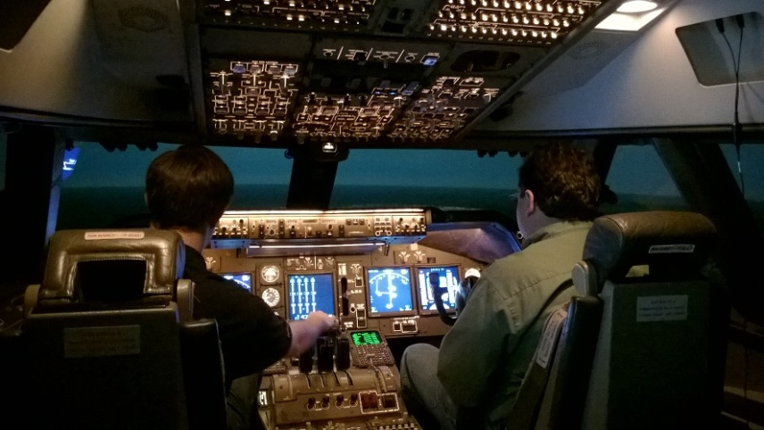

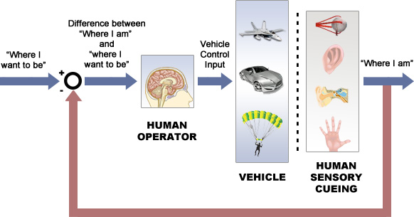

**Market/Customers & Collaborators**

**- Government Customers**

**Navy: NAVAIR, NAVSEA, ONR, NAWCTSD**

**Air Force: AFRL, AFTC, AFOSR**

**Army: ARL, AMRDEC, TARDEC**

**NASA: AFRC, ARC, GRC, JSC, LaRC**

**DOT: FAA, FHWA, NHTSA**

**DHHS: CDC, NIA, NIH, NIOSH**

**DOI: USFS**

**- Industry Collaborators**

**Bell Helicopter**

**The Boeing Company**

**General Atomics – Aeronautical Systems, Inc.**

**Lockheed Martin**

**Moog, Inc.**

**Northrop Grumman**

**Sikorsky**

**Textron Cessna**

**- International Collaborators**

**Embraer**

**Contract Vehicles**

**- SBIR/STTR**

**- BAA**

**- IDIQ**

**- NRA**

**- Commercial Consulting**

**Core Competency**

**- Analysis of Dynamic Systems**

**- Flight Control System Design and Analysis**

**- Assessment of Handling Qualities including PIO**

**- Flight Test and Piloted Simulation**

**- Human Operator Models**

**- Advanced Cockpit Displays**

**- Aeroservoelastics**

**- System Identification**

**Emerging Technology for the Navy**

**The Adaptive Shipboard Guidance and Recovery Display (ASGaRD) supports single pilot shipboard recoveries under zero-zero conditions with a set of intuitively integrated guidance and spatial cues that are optimized to enhance pilot-vehicle system performance and safety.**

**With outside visuals not available, ASGaRD includes animation of a moving ship deck that provides pilots with enhanced situational awareness.**

**Guidance symbology leads the pilot to the desired shipboard approach and recovery.**

**For Navy helicopter pilots, ASGaRD's advanced guidance and symbology will reduce pilot workload and enhance safety when outside visual cues are not available under these challenging conditions.**

**ASGaRD will meet Navy objectives via a software solution that is compatible with the existing multi-function cockpit displays of the MH-60R thereby allowing for rapid fleet integration.**

**Company History**

**Systems Technology, Inc. (STI) is a small employee-owned research, consulting, and product development firm located in Hawthorne, California.**

**Founded in 1957, STI has been devoted to the study of vehicle dynamics, control, and related human factors for nearly sixty years. STI focuses on aircraft dynamics, aerodynamics, flight control system design and analysis, handling qualities, and manual control theory.**

**Mission/Vision Statement**

**We develop engineering solutions for complex moving machines and the humans that control them, from aircraft to automobiles.** **Our engineering consulting services and simulation products bridge the** **gap between advanced engineering and human factors.**

