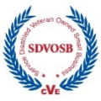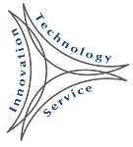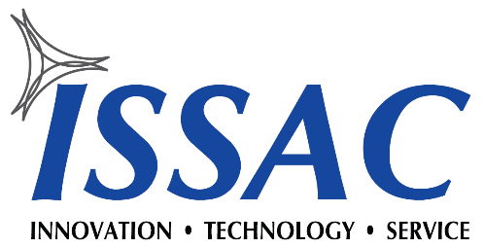

Capabilities

ISSAC provides a novel approach to System of Systems (SoS) Engineering using a standards driven Model Based Systems Engineering (MBSE) method. We provide innovative solutions to the most challenging issues facing our customers, such as integration and interoperability and analysis of complex data sets. Our primary areas of focus include:

* Big Data Analytics
* Modeling and Simulation (M&S)
* Model Based Systems Engineering (MBSE)
* System of Systems Engineering (SoSE)
* Software Development/Engineering
* Lifecycle Knowledge Management
* Data Management and Normalization

Service Disabled  
Veteran Owned Small Business

Innovation

ISSAC has developed specialized data fusion and analysis products first leveraged by the Missile Defense Agency. Our innovative analytics technology, ***VOR™***, is applicable to nearly every industry and is being productized in several key commercial sectors.

We offer our clients our advanced technology for parsing, ingesting and semantically analyzing data for valuable and timely new insights and discoveries. We can automatically analyze huge data sets to provide enlightened solutions and focus on knowledge discovery by automatically building data relationships. Our revolutionary technology is applicable for any data set in any industry and provides speed and accuracy with cost efficiency.

***VOR™*** Analytics is comprised of data mining, data fusion, knowledge management, and integration and interoperability models which are based on advanced research in a multitude of subjects. Our award-winning and collaborative approach is applicable to both Department of Defense and commercial industry applications.



We have developed data management tools used to support the discovery phase of Systems Engineering via a MDA sponsored SBIR program. Expanding our SBIR efforts, we have heavily invested in R&D efforts that provide industry leading technologies in data analytics. These analytics tools are receiving international recognition and form a platform to serve many customers.





Who We Are

ISSAC (Innovative Scientific Solutions & Analytics Corporation) is an Advanced Data Analytics and Systems Engineering company with corporate headquarters in Colorado Springs, Colorado, and operations in Huntsville, Alabama. ISSAC was founded on the concept of providing only the most technically-advanced individuals and solutions in support of our customers. Our team is totally committed to our customers.

We demand professionalism, honesty, and integrity from our team. As we continue to build our team, we will only seek out professionals who are technically advanced, leading the fields in which they have positioned themselves, and who have the moral character to be integral and dynamic members of our organization. This endeavor requires a team – one that is committed to a common goal. Founded in 2006, ISSAC is focused on three primary areas: Innovation, Technology and Customer Service.



Contact Us

**HSV: Mike.Feltman@ISSACcorp.com, (256) 603-0707  
 COS: Tom.Sheehan@ISSACcorp.com, (719) 725-6904**



ISSAC Corp Copyright © 2019

***www.ISSACcorp.com***

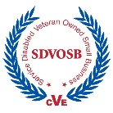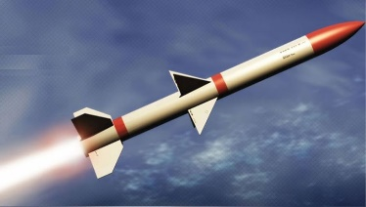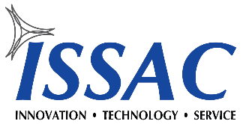

Cyber

ISSAC is working in ***Cyber Analytics*** for the investigation and discovery of complex data sets. ISSAC

***Cyber Analytics***

Defense

ISSAC has broad experience across DoD having worked contracts with the Navy, Air Force, and Army. Our work in



uses ***VOR™*** to interrogate multiple datasets using advanced Mining, Relationship Identification, and Data Association/Correlation. With selected ***VOR™*** modules, ISSAC can analyze complex datasets and extract meaning from dark data.   
Processes include:

* Threat Hypothesis Generation
* Automation of Repetitive Tasks
* Indications and Warnings Assessment
* Course of Action Development
* Information Evolution
* Threat Discovery

***Cyber Anomaly Discovery***

modeling and control of energy grids for real-time topology modifications to preserve critical functionality.  
***OptimumVĪS™*** can generate topological hypotheses and create optimal solutions for each hypothesis.  
The analytics engine in ***VOR™*** can also been used in applications to optimize energy storage and peak power avoidance with solar, wind, and thermal energy, as well as storage for optimization of diesel generators. Key technologies include machine learning, abductive reasoning, hypothesis generation, belief analytics, metaheuristics, pattern-based techniques, and uncertainty quantification.

ISSAC Corp Copyright © 2016

***Energy Grid Optimization***

***OptimumVĪS™***

Energy Grid

***OptimumVĪS™*** is used to perform power grid analysis and management by means of dynamic, adaptive, prescriptive analytics. It can handle the monitoring,

Health Care

ISSAC has been working with TGen and MAYO Clinic using ***VOR™*** Analytics for clinical trial research and genomic

analytics. This effort has already produced multiple discoveries (from data thought to be useless) which will help guide future research and treatment. These discoveries are significant and have been published in medical journals. The amount of data to analyze in and around the healthcare industry is overwhelming, but ISSAC is making strides in the search for a cure. Using ***VOR™***, healthcare professionals can research genomic history, health records, family history, pharmacology, medical trials, and complex illness history to produce advanced, unique, effective treatment recommendations.

Contact Us

Huntsville: Mike Feltman, (256) 603-0707  
Email: Mike.Feltman@ISSACcorp.com

Colorado Springs: Tom Sheehan, (719) 725-6904  
Email: Tom.Sheehan@ISSACcorp.com

***LysaLog™***

***Logistics Optimization***

Logistics

LysaLog™ takes on the challenge of optimizing Load Scheduling, Load Pairing, Routing, and Maintenance.

It can be used on all transport types including trucking, oceanic shipping, railway, and air. LysaLog™ provides a cloud-based environment to ingest vehicle diagnostics, GPS location, and load information to provide real-time decisions and solutions.

support of the war fighter has included extensive work in M&S with System of Systems Engineering, Model-Based Systems Engineering, Data Fusion, Data Management, and Data Analytics. Work with Boeing on GMD has resulted in ISSAC being a Boeing Gold Level Supplier for many years. Navy work has included Electric Ship Power Optimization in collaboration with UT-Austin Center for Electromechanics. ISSAC is a teammate on numerous contracts, including:   
 ● AMCOM Express ● JFFT - CybEx ● GSA PSS  
 ● NT-E Boeing ● MDA & Navy STTR ● DHHS IAAI  
 ● DOMS ● SEAPORT-NxG ● I2MT

***www.ISSACcorp.com***

***VOR™ Analytics***

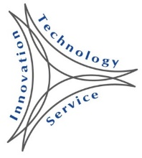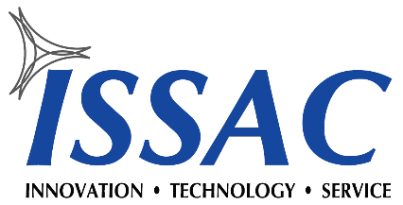

*Illuminating Data to Create Knowledge and Wisdom*

***www.ISSACcorp.com***

ISSAC has developed specialized data fusion products first used by the Missile Defense Agency. Our innovative technology, VOR™, is applicable to any industry and is being productized in several key commercial sectors.   
VOR™ delivers a platform technology that can be applied to any large data set and provides analysts with powerful, automated analytics.

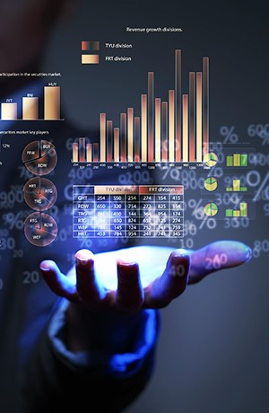

***VOR™ service-based technology includes:***

* Data and information ingestion, correlation and fusion, while eliciting information from subject matter experts and stakeholders
* Modeling, simulation and analytics that leverage optimization and uncertainty quantification with concept exploration, forensic investigation and model evolution
* Fundamental structural, search and analysis mechanisms for knowledge management, including ad hoc data types, clustering, gap analysis and SPIDR™ (Evolutionary Learning Algorithms)
* Complete and integrated Systems Engineering life cycle management process.

***VOR™ provides powerful capabilities including:***

**• Semantic Ingestion • Descriptive, Predictive, Prescriptive Analytics**

**• Concept Repository • Concept Resolution**

**• Machine Learning • Basic Visualization**

**• Knowledge Discovery • External, Standard API’s**

**• Hypothesis Generation • SOA-based Architecture**

**• Optimization • Management**

**• Confidence Assessment • Mixed-Initiative Learning**

**• COA Recommendations • Inductive, Deductive, Abductive Reasoning**

***VOR™*** augments decision cycles, enhancing analytical output through automation, guiding the decision making of analysts. With automation built throughout the products, analysts can quickly produce knowledge and wisdom from any complex data set. Options are available to use one of the current ***VOR™*** products or a custom API to meet specific needs. Multiple deployment options are available including cloud processing via AWS.



***VOR™*** produces results that are insightful and powerful, which drive new paradigms in business and science.

***VOR™*** provides powerful analytics capabilities directly into the hands of decision makers, with the flexibility to handle a huge diversity of tasks and uses.

ISSAC Corp Copyright © 2019

More Details on Back Side

Contact Us

Huntsville: Mike Feltman, (256) 603-0707, Mike.Feltman@ISSACcorp.com  
Colorado Springs: Tom Sheehan, (719) 725-6904, Tom.Sheehan@ISSACcorp.com

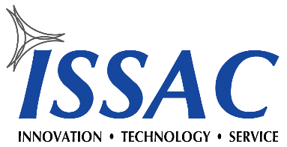

***VOR™ Analytics***

Illuminating Data to Create Knowledge and Wisdom

Process Flow

***VOR™*** provides a standard environment and process for the capture, normalization, management, association, and analysis of information. The goal is for the analytical environment to provide great data integrity in which to explore and extract meaning from information and transform it into quality actionable knowledge and wisdom.

Our technology allows the use of the organic form (the shape, structure and density) of the knowledge base to identify gaps and overlaps or conflicts in information without the need to interrogate the data or metadata on each node. Using Semantic Ingestion, data is inserted into a graph database which supports all other analysis activities.

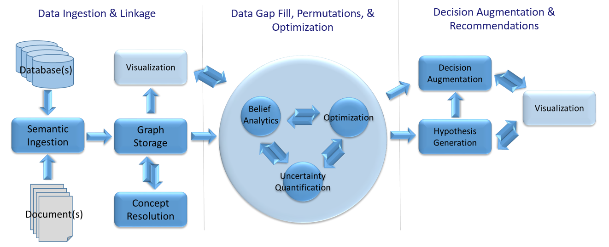

ISSAC Corp Copyright © 2019

ISSAC Corp fuses these technologies and capabilities into a single environment that produces actionable information to be used throughout the engineering lifecycle of a system or SoS.

With the ever-growing complexity and scale of today’s systems and processes, difficulties are evident in effectively interrogating all of the possible states and parameter interactions in a meaningful way, during concept exploration and design. This exploration is necessary to determine sensitivities in potential system alternatives before they manifest into catastrophic failures resulting in significant monetary and human losses.

Current approaches to this problem focus on modeling component performance through discrete event or agent-based techniques, typically leveraging Monte Carlo approaches for parameter reduction. **VOR™** approaches the problem from an abstract perspective: extracting and modeling the cause and effect processes (including business processes and human decisions/actions) and their resultant behaviors using Credal Networks and embedding them with multi-dimensional PDF’s that describe each processes behaviors/performance. Each causal hypothesis extracted provides a concise model of the entire system or SoS and possible employment strategies and decision logics that may be utilized in the real system. Through rapid simulation, **VOR™** computes millions of parameter permutations in minutes and determines possible failure conditions, bifurcations of state, optimal architecture and employment strategies (TTP and CONOPs).

***VOR™*** is built on many accepted mathematical and modeling and simulation paradigms which are fused together to create novel processes and tools:

**• Bayesian and Credal Networks • Multi-level Abstraction and Behavior/Performance Matching**

**• Decision Science • Graph Modeling**

**• Deep Analytics • Stochastic Simulation**

**• Uncertainty Quantification • Optimization**