**ΙΦΩΣ = Intelligent *Light***

**Place Logo Here**

**Contact IFOS**

2363 Calle Del Mundo, Santa Clara, CA 95054

Tel.: +1 408 565 9000

[info@ifos.com](mailto:info@ifos.com)

www.ifos.com



**Our Resources**

IFOS is located in the City of Santa Clara, at the heart of Silicon Valley, CA. The main facilities are approximately 10,000 square feet, which houses the laboratories, management, business and engineering personnel offices and equipment. IFOS laboratories are supplied with the state-of-the-art equipment necessary for the investigation, fabrication, characterization, testing and evaluation of fiber-optic and photonic devices, sensors, systems and networks.

IFOS develops innovative and robust technology by utilizing its resources and motivated employees:

* 10,000 sq. ft. facilities in Silicon Valley near Stanford University
* Engineers and scientists with over 100 years combined experience in fiber optics sensing
* Teaming with leading Silicon Valley contract manufacturers



**PICTURE**

**Quad Chart Picture (if appropriate)**

This company formed in Silicon Valley as Intelligent Fiber Optic Systems Corporation in 2001. In 2006, IFOS purchased all assets of venture capital backed San Diego based oil & gas company Oluma™. At about the same time, IFOS began a series of collaborations on the development of optically sensorized/activated medical devices and fiber optic gyroscopes.

IFOS is continuously strengthening its management, business development, marketing, sales and engineering team and continues to leverage its experienced, multidisciplinary team of alumni, current professional staff and world class consultants to develop and commercialize new fiber optic sensing products and solutions to serves the needs of aerospace, energy and medical devices markets.

**Mission/Vision Statement**

- Mission (external mission statement)

- Supporting principles (if any)

- Values (similar to supporting principles – but more ephemeral



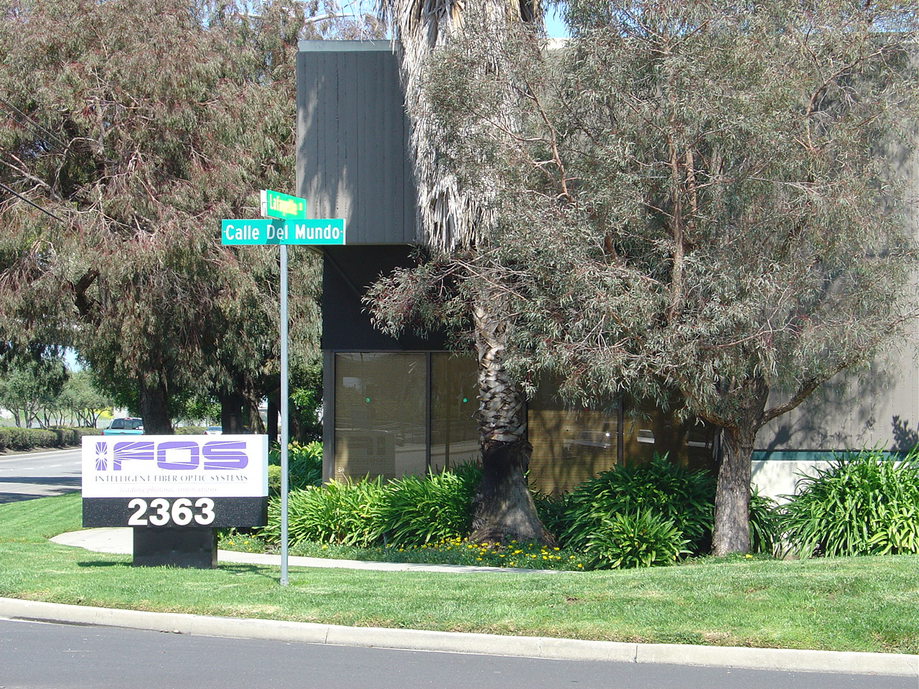

Picture of what the benefit is of your technology/service.

**Market/Customers**

- Customer list – Government

- Customer List-Private

- Customers- International

**Contract Vehicles**

- List of contract vehicles

**Core Capabilities**

IFOS develops pioneering, yet cost-effective optical fiber sensing system level products for the monitoring and control of temperature, static load, dynamic strain, acoustic emission and derived physical, chemical and biological measurands for the maintenance and prognostics of critical high-value assets in harsh and demanding environments, to 1000°C, 1 kBar and high radiation levels.

**Aerospace**

I*Sense™ 48K: static and dynamic measurement of strain from pico-strains to explosions at 6 kHz, temperature measurements to 1000°C

- I*Sense™ 48K-MS-HC: can monitor 1,000+ FBG sensors

- I*Sense™ HS48M: ultra-high-speed dynamic strain and combined vibration, acoustic and ultrasonic measurements to 3 MHz in NDE, structural analysis and HUM, SHM and prognostic CBM in composite and metal structures

**Research**

- relevant ongoing phase 2 projects

R&D

- Production

- Services

- Call out any significant team accomplishments

- Patents

- Big awards or milestones

- Any big press releases or contract awards