Who we are:

RKF was founded by Phil Rubin, Ted Kaplan, and Jeffery Freedman in 2001 with the goal of pushing the boundaries of RF Engineering.
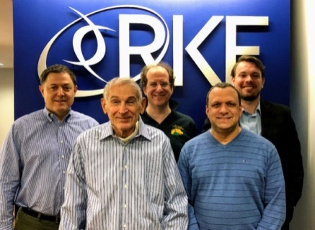

Throughout our history, we have worked extensively on a wide variety of cutting-edge communications systems ranging from satellites to terrestrial networks to high-altitude platforms. Today, we are doing work alongside the leaders of the wireless communications industry, such as DirecTV, DISA, Intelsat, Facebook, Google, NASA, SEAKR, and SES.

Contact Us
7500 Old Georgetown Road, Suite 1275
Bethesda, MD 20814-6198
Phone: (301)-298-7580
http://rkf-eng.com

David Milliner
Email: DMilliner@rkf-eng.com

Boldly going where no communication technology has gone before

What do we do?
Satellite Systems
RKF provides engineering expertise for the conceptualization, development, and improvement of satellite systems, including geostationary and non-geostationary satellite constellations and high altitude platform systems (HAPS).
Terrestrial Systems
RKF provides engineering expertise for the conceptualization, development, and improvement of terrestrial systems.
Hardware Design
RKF designs a wide variety of hardware for terrestrial and satellite networks.
Advocacy
RKF advocates for the acquisition and protection of spectrum on behalf of clients both corporate and governmental around the world. These efforts occur at the national, regional, and global levels, culminating in the World Radio Conference (WRC), where the international rules for spectrum use are set.
Modeling & Simulations
RKF creates simulations and models of wireless communications systems. In our work with satellite systems, we have used simulations to support the conceptualization, design, and development of satellite communications payloads with on-board digital processing as well as conventional bent-pipe designs.
This work includes systems in all orbits (LEO, MEO, HEO, GEO) and all operating bandwidths (S-band, L-band, C-band, Ku-band, Ka-band). In our work simulating terrestrial systems, we have developed LTE, WiFi, and 5G models, and traffic, and clutter models to create highly-realistic dynamic simulations of systems utilizing these technologies.
What have we done?

Advancing NASA Space Networks
RKF has served as subject matter experts for the Tracking and Delay Relay Satellite program in addition to proposing future space communication architectures for NASA headquarters.
Image Courtesy of the U.S. Navy

Inputs to DARPA’s Tactical Technology Office
RKF has provided their expertise in wireless communication and networking for multiple DARPA projects, including supporting the formation of a flying space constellation as well as developing system that counter Unmanned Aerial Vehicles (UAVs).
Navy work

HOT nAILES (Hybrid Open Transceiver new Advanced Integrated Line-of-sight Equipment System)
We will be modernizing the RF distribution system with digital internals and include efficient High-Powered Amplifier with low interference products being sent into the electromagnetic environment. By employing modern technologies improved frequency hopping performance/capability are being enabled while also achieving reductions in SWAP-C.
