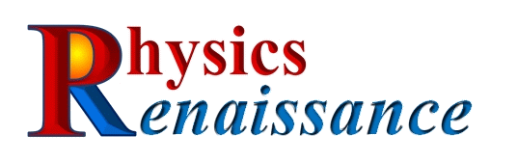
Putting physics to work for you!

About Us
Physics Renaissance LLC provides basic and applied scientific and engineering research and development services for both industrial and military
customers. Our team of subject matter experts cover a wide variety of technical areas in the fields of Physics, Mechanical, and Electrical Engineering. We specialize in developing non-traditional solutions to difficult problems and provide our customers with the insight and tools they need to solve complex problems.

Do you have a problem that seems impossible?
We love to challenge the status-quo and work with your team to provide the innovative solutions you're looking for!

Products/Services
Physics Renaissance specializes in developing innovative advanced sensor technologies to address problems critical to the fields of vehicle testing, health monitoring, smart sensors and condition based maintenance. An example is a “smart” sensor for in-situ monitoring of fatigue induced cracks and wear around a structural fastener. Our sensor easily integrates with the structure and can be used in systems ranging from aircraft, vehicles, ships, spacecraft, and infrastructures. The functionality and innovation of this technology has been tested and validated for different varieties of structures including combinations of titanium, aluminum and carbon composites. The current goal is to take this technology, which has been successfully demonstrated and tested in a lab relevant environment, and develop it for use in commercial and military operational environments.
Physics Renaissance is transitioning this technology into government and prime contractor systems for facilitating condition based maintenance solutions.
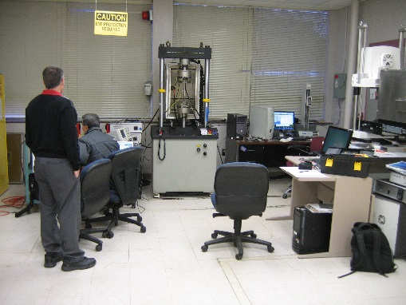
NAVAIR Crack detector testing
at the University of Alabama in Huntsville Reliability and Failure Analysis Lab.
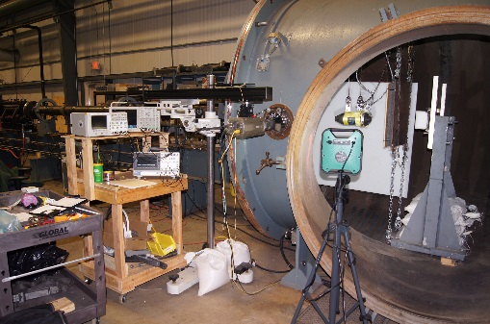
High Speed Impact Structural Test & Analysis for military equipment survivability.

TECHNOLOGY EXPERTISE
- MEMS/NEMS
- Microfluidics
- Infrared Detectors
- Neural Networks
- Fourier & Wavelet Signal Processing
- High Speed Phenomenon
- Nuclear Effects Testing
- Microwaves & RF
- Electronics design
- Flight Hardware
- Ground Support Equipment

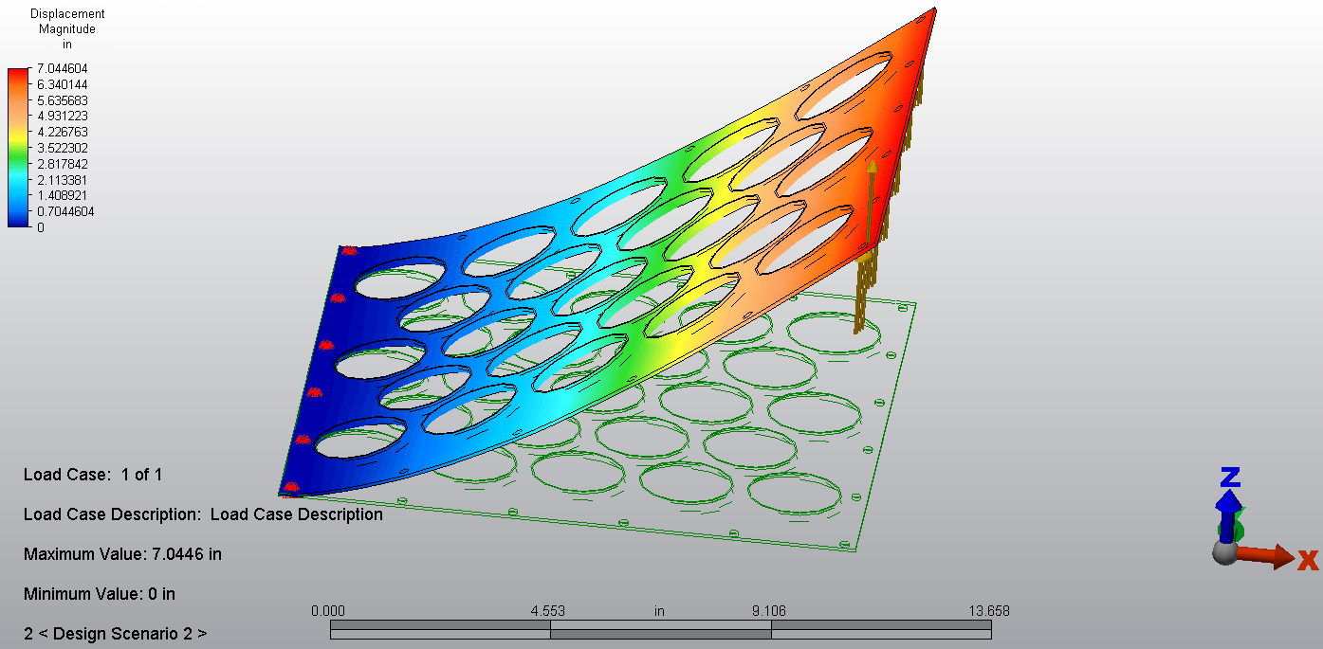

INDUSTRY EXPERIENCE
- DOD (Army, Navy, Air Force, Marines, PEO STRI, TACOM, AMRDEC, RDECOM, SMDC, MDA, DIA)
- Strategic Missile Defense
- Tactical Missile Defense
- NASA
- Commercial Products

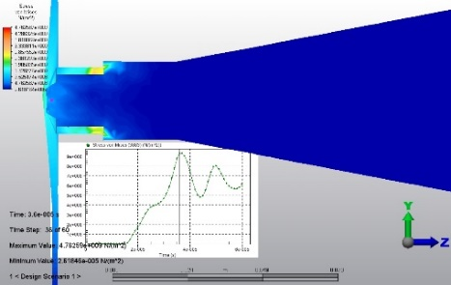

BUSINESS DEVELOPMENT
• Small Business Innovative Research (11 Phase I, 8 Phase II )
• Broad Agency Announcements (~$6M AMRDEC Warheads BAA, PEO STRI BAA)
• Other Transaction Agreements (OTAs) (~$0.5M Non-Traditional DOTC Consortium Contracts)
• Large ID/IQ Proposals (O2K, AMCOM EXPRESS, DS-TATS, etc.)

TECHNICAL SPECIALIZATIONS
- MATLAB
- Simulink
- MathCad
- Mathematica
- Fortran
- C & Javascript
- ZEEMAX
- Autodesk® Multiphysics
- Autodesk® CFD
- FEMM
- CTH Hydrocode
- Solid Works®
- Altium Pro®
- HVAC Design

Physics Renaissance LLC
108 Sunscape Drive Huntsville, AL 35806
(256) 200-9583
info@phy-ren.com

Visit us at www.phy-ren.com

Physics Renaissance LLC is a veteran owned small business equal opportunity employer.

