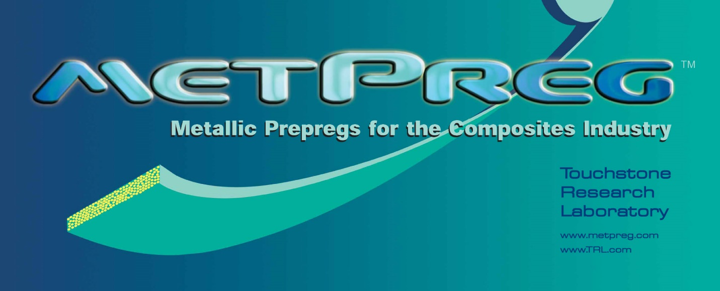

The World’s Strongest Aluminum
and
The World’s Highest Temperature Thermoplastic Composite
Straddling the worlds of metals and composites, MetPreg® is revolutionary. With a tensile strength over 210 KSI, MetPreg has a strength more than two and a half times greater than the strongest aluminum alloys (and a stiffness 3 times as great) and with an operating temperature range in excess of 1000°F, MetPreg is the world’s highest temperature thermoplastic composite material.
MetPreg is inexpensive to process and is capable of making very large parts.
MetPreg stands to revolutionize the way we build aircraft, rockets, missiles, engines, guns, automobiles, trains and watercraft.

MetPreg is protected by the following patents with many more pending
US7498077, US7591299, US7774912, US7186948, US7164096, US6455804, US7170028, US7681625
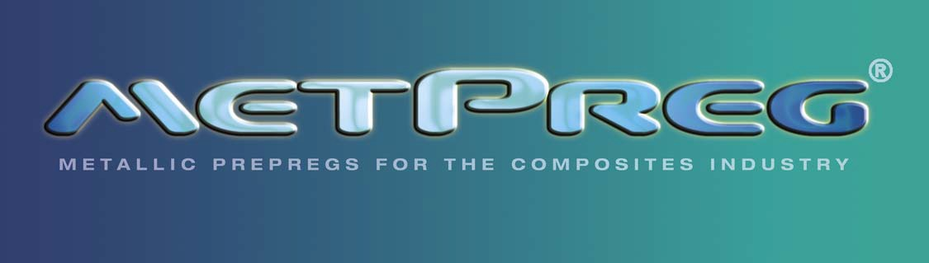

FILAMENT WINDING

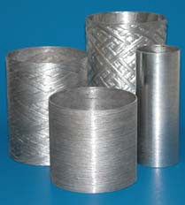
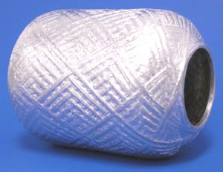
This technology is ideal for:

- Rocket motor cases
- Pressure vessels
- Aerospace storage tanks
- Ordnance items
- Hydrogen fuel tanks
- Tubular structures

MetPreg® Filament Winding – A Breakthrough Technology
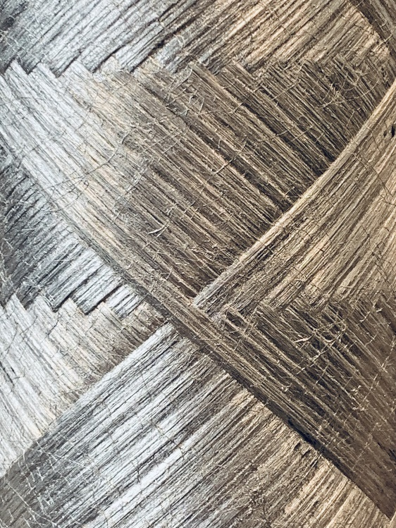
Fiber reinforced aluminum is enabling for applications requiring stiffness and strength especially at high temperatures. Filament winding has been around for decades and remains one of the most cost-effective methods for mass production of composites. The confluence of these two technologies, namely a low-cost filament winding process with high-performance metal matrix composite materials, can lead to great improvements in the ability to produce affordable MMC structures by driving down costs and improving manufacturing capabilities.

Touchstone Research Laboratory has developed a process to filament wind its MetPreg metallic prepregs. This breakthrough process can be used for manufacturing cylinders, spheres, or other shapes.
Hydrostatic burst testing on finished cylinders has demonstrated translation efficiencies of more than 85%.
MetPreg filament wound vessels have excellent burst pressure, longitudinal and torsional stiffness, and compressive strength. The compression strength for these materials can be as high as 4.0 GPa (580 ksi), which makes them ideal for gun- launched ordnance applications where high compressive loads are experienced. These properties are maintained at high temperatures. The benefits offered by this technology could easily provide weight reduction opportunities for structural engineers and designers.

FILAMENT WINDING

MetPreg® Filament Winding Features
- Highly repetitive part-to-part fiber placement
- Large structures can be built without costly casting mold investments
- Low-cost manufacturing process
- High fiber volume attainable
- Continuous fiber used over entire component area
- Maintains 85% of its room temperature longitudinal tensile strength to greater than 700ºF
- Field repairs are possible with soldering and brazing equipment
- Permeability of H₂ through the aluminum matrix is negligible
- Compatible with liquid O₂ and many propellant chemistries
- Does not microcrack at cryogenic temperatures
- Does not outgas under vacuum
- Properties are unaffected by high humidity
- UV exposure causes no degradation of properties
- Electrically conductive − no static charging
- Coefficient of thermal expansion is approximately half that of aluminum
- Integral flanges and end closures for pressure vessels can be wound-in
- Remains impermeable to He after 100 cycles between -450°F and 250°F
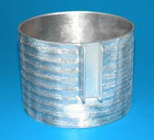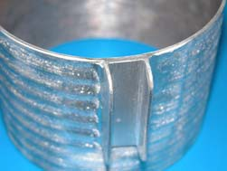

Typical Properties of MetPreg® Cylinders (50% Fiber Volume Fraction, 4060 psi Burst)
Density (g/cm³) | 3.30
Wall Thickness, in | 0.095
Weight per Linear Inch, lb/in | 0.24
Internal Volume per Linear Inch, in³/in | 36.4
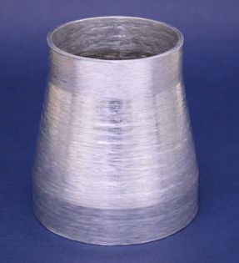

The test data presented in this bulletin is believed by Touchstone to be representative of this product. However, the test data are not a guarantee or warranty. Touchstone makes no warranty, whether expressed or implied, including warranties of merchantability or of fitness for a particular purpose. Under no circumstances shall Touchstone be liable for incidental, consequential, or other damages arising out of a claim from alleged negligence, breach of warranty, strict liability or any other theory, through the use or handling of this product or the inability to use the product. The sole liability of Touchstone for any claims arising out of the manufacture, use, or sale of its products shall be for the replacement of the quantity of this product which has proven to not substantially comply with the data presented in this bulletin. Users should make their own assessment of the suitability of any product for the purposes required. The above supersedes any provision in your company’s forms, letters, or other documents

METALLIC PREPREGS

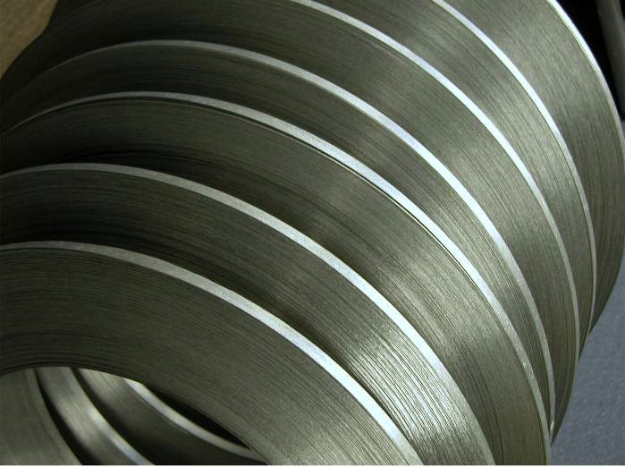

MetPreg® − What is it?
A prepreg is a combination of a matrix and fiber reinforcement. MetPreg is a metallic prepreg consisting of aluminum and continuous ceramic fiber reinforcement. MetPreg is analogous to prepreg units of construction commonly employed in polymer matrix composite fabrications. MetPreg can be processed in several different ways, with the most appropriate method chosen based on the particular application. Processing methods include:

- Filament winding
- Tape placement
- Hot pressing
- Hand lay-up
- Adhesive bonding
- Brazing

Metallic prepregs far exceed monolithic aluminum longitudinal tensile and compressive strengths, thereby providing an efficient option to structural engineers and designers interested in components that exhibit high specific (property value divided by material’s density) strengths and elastic moduli.

MetPreg − Is it commercially available?
Yes, Touchstone Research Laboratory, Ltd. is now providing MetPreg in multiple sizes to composite part designers, fabricators, and system integrators.

MetPreg Sizes Available
MetPreg is available in nominal sizes as follows: Width: 0.25 to 1.25 in. (6.4 to 32 mm)
Thickness: 0.008 to 0.030 in. (0.20 to 0.75 mm)
Length: Continuous strips to 1000 feet
MetPreg can also be produced in the form of tubes, angles, channels, etc.

MetPreg − Special Coatings
Metallic prepregs having a surface coating (typically 0.002 inch thick) of a lower melting alloy than the matrix alloy can be supplied upon special request. The surface coating aids brazing and welding to other tapes and to bulk aluminum.

METALLIC PREPREGS

MetPreg Features
- Lightweight and strong: Twice the specific strength and stiffness of structural aluminum alloys (Example: AA7075-T6 has a UTS of 83 ksi and E of 10.4 Msi with a YS of 73 ksi. Please compare these values with those of MetPreg in the chart to the right).
- Can be welded, soldered, brazed and bonded with structural adhesives
- Maintains 85% of its room temperature longitudinal tensile strength to greater than 700ºF.
- Field repairs are possible with soldering and brazing equipment
- Permeability of H₂ through the aluminum matrix is negligible
- Compatible with liquid O₂ and some propellant chemistries
- Does not microcrack at cryogenic temperatures
- Does not outgas under vacuum
- Properties are unaffected by high humidity
- UV exposure causes no degradation
- Electrically conductive − no static charging
- Can be handled in processing steps similar to polymer composites
- Coefficient of thermal expansion is approximately half that of aluminum
- MetPreg can be thermally formed and set to a desired geometry
- Integral flanges and end closures for vessels can be made of MetPreg to minimize thermal stresses during cycling
www.MetPreg.com
Remains impermeable to He after 100 cycles between -450⁰F and 250⁰F

Typical Properties of MetPreg (50% Fiber Volume)
Bulk Density (lb/in³) | 0.12 (3.30 g/cm³)
Elevated Use Temperature (°F)* | 700 (370° C)
Tensile Strength (ksi) | 210 (1450 MPa)
Tensile Modulus (Msi) | 30 (207 GPa)
Tensile Strain to Failure (%) | 0.7
Compressive Strength (ksi) | 300 (2070 MPa)
*Temperature at which tensile strength is 85% of room temperature tensile strength

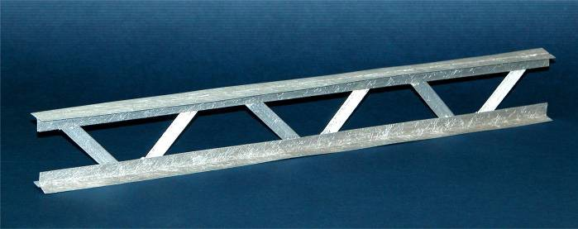

The test data presented in this bulletin is believed by Touchstone to be representative of this product. However, the test data are not a guaranty or warranty. Touchstone makes no warranty, whether expressed or implied, including warranties of merchantability or of fitness for a particular purpose. Under no circumstances shall Touchstone be liable for incidental, consequential, or other damages arising out of a claim from alleged negligence, breach of warranty, strict liability or any other theory, through the use or handling of this product or the inability to use the product. The sole liability of Touchstone for any claims arising out of the manufacture, use, or sale of its products shall be for the replacement of the quantity of this product which has proven to not substantially comply with the data presented in this bulletin. Users should make their own assessment of the suitability of any product for the purposes required. The above supersedes any provision in your company’s forms, letters, or other documents.

