**Advantage**

- Partners with University of New Mexico

- Established working relationships with:

Sandia National Laboratories

Office of Naval Research

US Army SMDC

Missile Defense Agency

White Sands Missile Range - SVAD

Air Force Research Laboratory – Kirtland AFB

HERTF Test Range

HEML Test Chamber

Raytheon Albuquerque

British Aerospace (BAE)

Leidos

Northrop Grumman

Verus Research

University of New Mexico

- Pulsed power systems concept through delivery

- Wideband HPM concept through delivery

- Value proposition

- Small and responsive

- DCAA, DCMA and DSS Compliant

- Secret FCL



Your Source for Pulsed Power Solutions

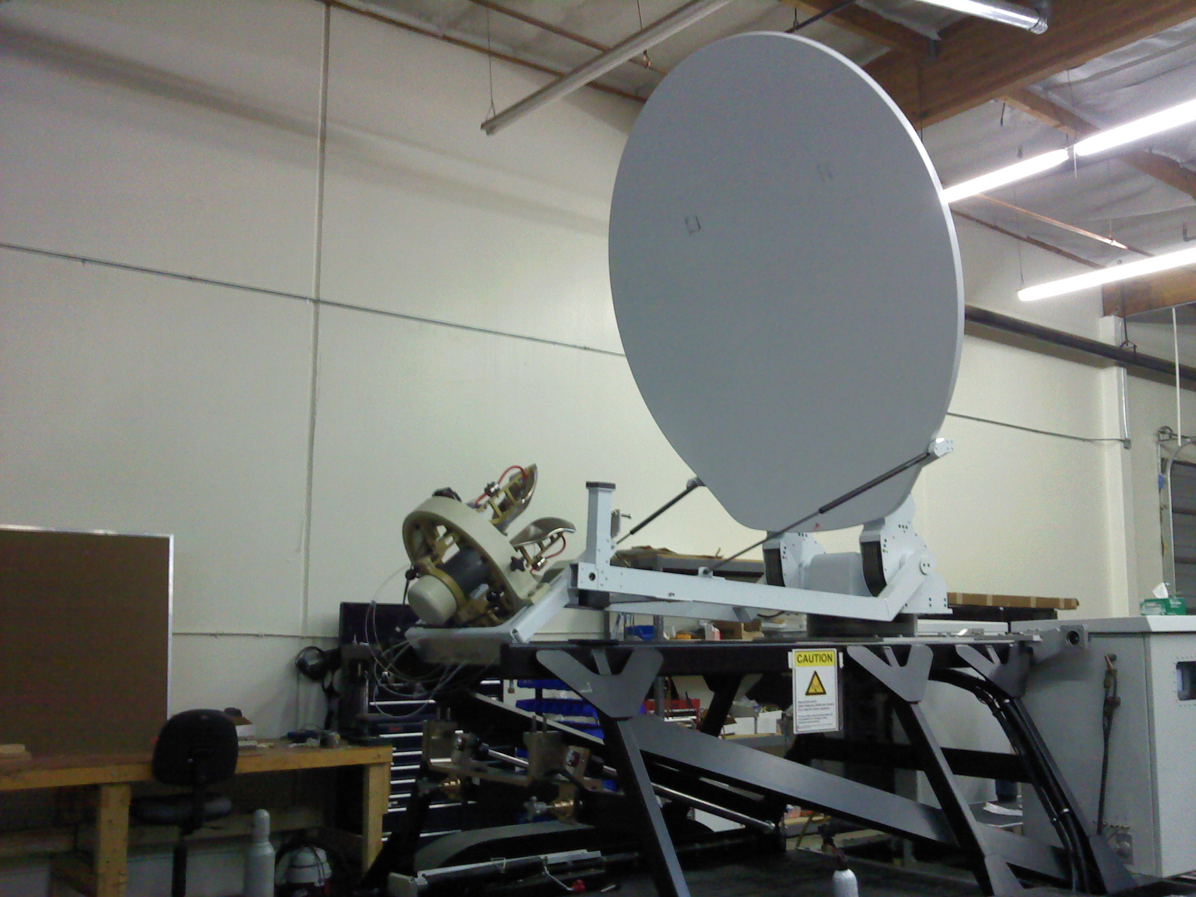

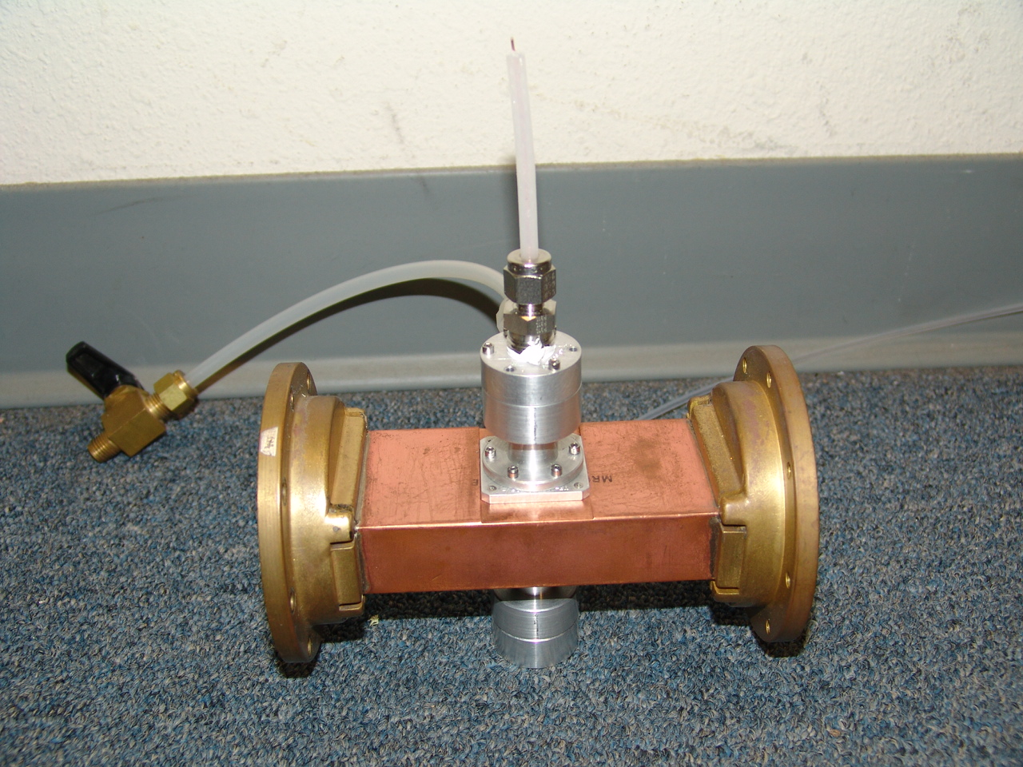 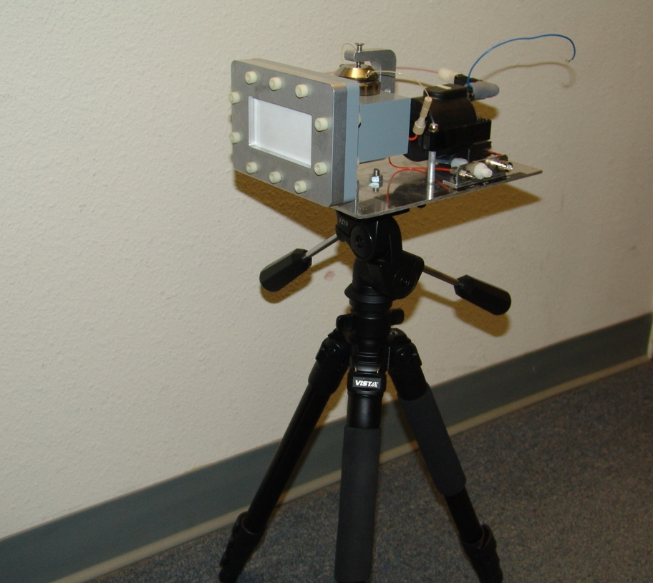

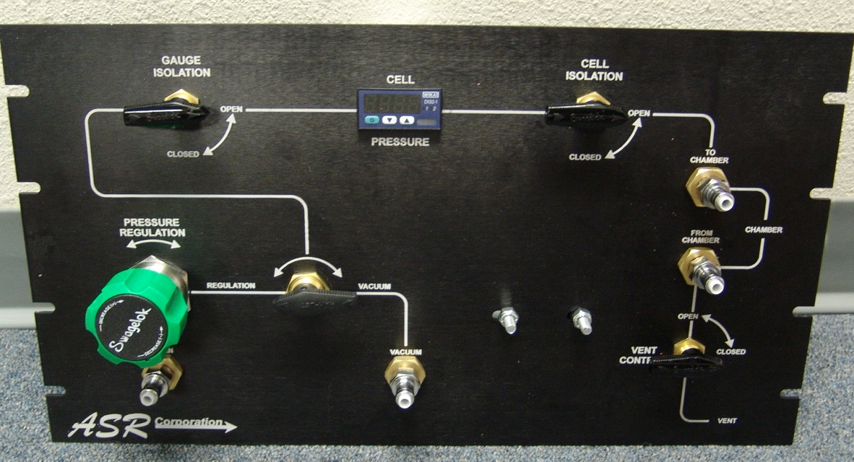 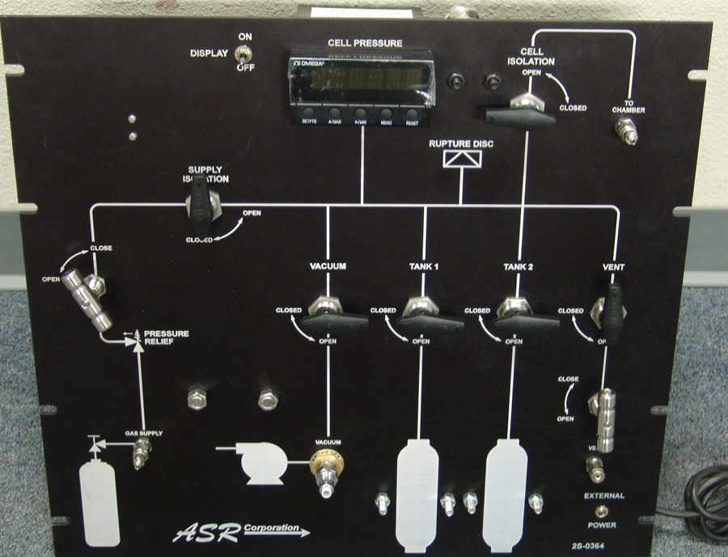

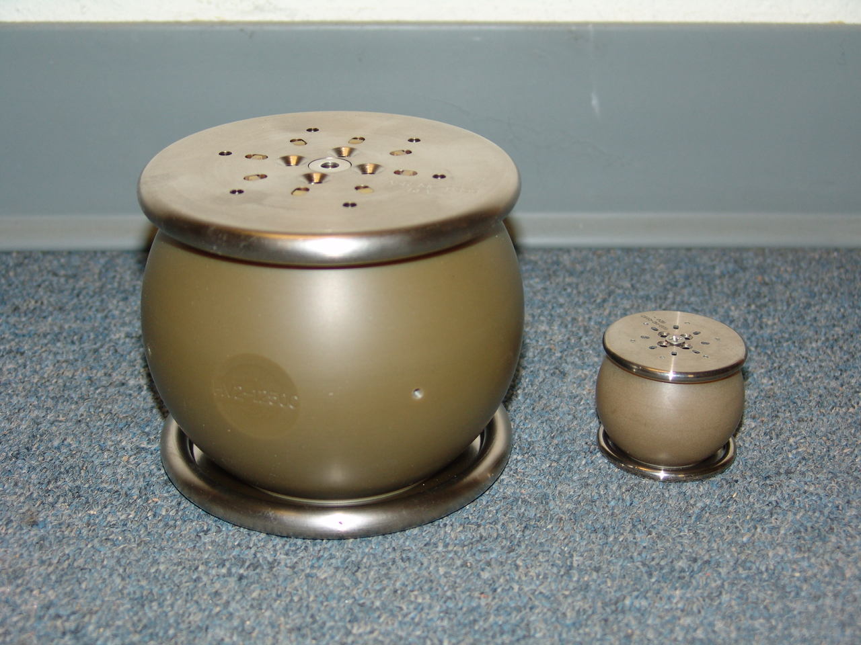

**Contact Us**

2301 Yale Blvd., SE

Albuquerque, NM 87106

505-830-3000

mda@asrcorporation.com

mcs@asrcorporation.com

www.asrcorporation.com

ASR Corporation



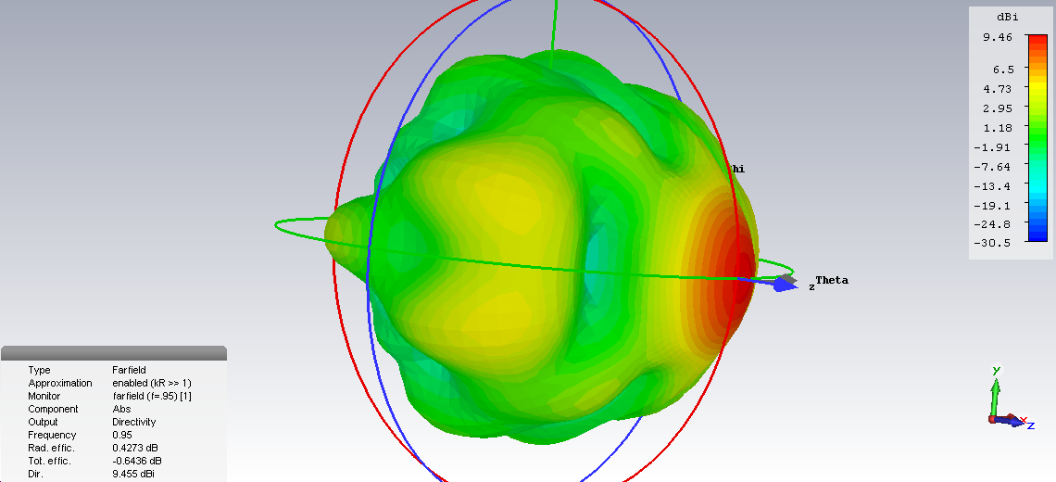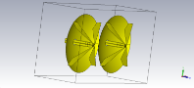

**Market/Customers**

- Air Force Research Laboratory

- Army Research Laboratory

- Navy Research Laboratory

- Ratheon Systems

- Techflow

- BAE

- Boeing

- Verus Research

**Contract Vehicles**

- Multiple SBIR/STTR Contracts

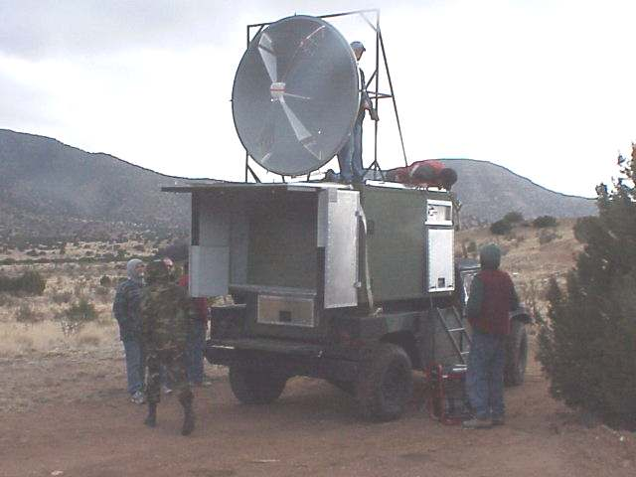

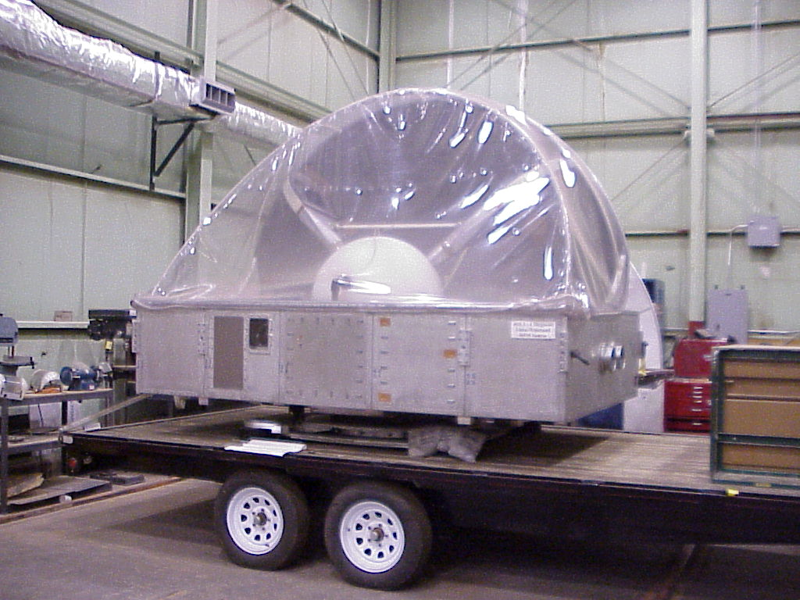

**Core Competence**

- Pulsed Power Research and Development

- Development of high voltage/power switch solutions

- Pulse forming systems

- Data acquisition and analysis

- Custom control system development

- Antenna system development

- End to end custom wideband source development

- System Test and Evaluation

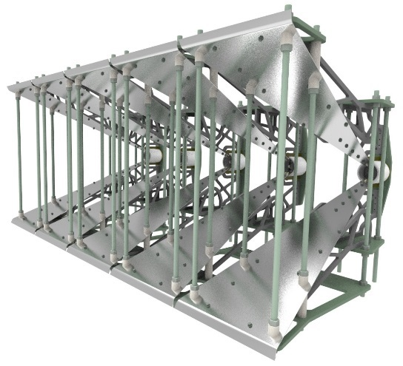

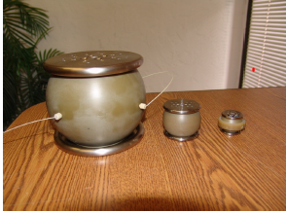



**Company History**

ASR Corporation was founded in 1992 to develop high power switches for DOD components.

**Mission/Vision Statement**

- Develop state of the art pulsed power technology for commercial and directed energy systems.

- Assist transition partners in moving our technologies to the warfighter.

